MED D - Test Claim - Calculating Quantity of Liquids

Definition | Liquid medications include elixirs, solutions, syrups and mixtures and are sometimes used in patients that have difficulty swallowing. They are also commonly used in children and the elderly.  Be careful not to confuse a Liquid medication with a Nebulizer Solution.
Instructions for Running a Test Claim | How many times per day does/will the beneficiary take the medication?  How many spoonfuls does/will the beneficiary take each time (teaspoon or tablespoon)?  For how many days will the beneficiary use the medication?
Additional Notes | Teaspoon Dosage  - Number of teaspoonfuls taken each day X 5cc = total cc/day.  - Total cc/day X number of days medication will be taken = total QTY to enter.  Tablespoon Dosage  - Number of tablespoonfuls taken each day X 15cc = total cc/day.  - Total cc/day X number of days medication will be taken = total QTY to enter.  Measurement Conversions  Refer to the following table:
Additional Notes | 1cc | = | 1ml |  | 3785cc | = | 1 gallon
Additional Notes | 5cc | = | 1 tsp |  | 1000cc | = | 1 liter
Additional Notes | 30cc | = | 1 oz |  | 16 oz | = | 1 pint
Additional Notes | 15cc | = | 1 tblsp |  | 32 oz | = | 1 quart
Additional Notes | 180cc | = | 6 oz |  | 2 cup | = | 1 pint
Additional Notes | 240cc | = | 8 oz |  | 8 pints | = | 1 gallon
Additional Notes | 480cc | = | 1 pint
What if Test Claim Rejects | Review the rejection code to determine what caused the rejection. Once the rejection code is identified, access the proper work instruction and job aids in theSource to help you resolve the issue.

Example
Trileptal Susp
300mg/5ml

Directions: Take 2 teaspoons daily
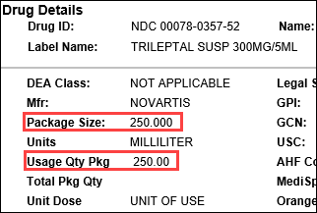 |  |  | 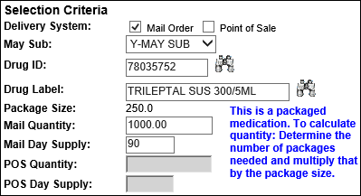
Calculation
CC per Day | X | Days |  | = | CC Needed
10 | X | 90 |  | = | 900
CC Needed | ÷ | Usage Quantity Package  (from PeopleSafe) |  | = | Total Packages Needed
900 | ÷ | 250 |  | = | 3.6 (Round up to 4)
Total Packages Needed | X | Package Size  (from PeopleSafe) |  | = | Test Claim Quantity
4 | X | 250 |  | = | 1000

Top of the Document

Related Documents
MED D - Test Claim Index
Calculating Quantities for Packaged Medication

Parent SOP: CALL-0049: Customer Care Internal and External Call Handling
Abbreviations / Definitions: Customer Care Abbreviations, Definitions, and Terms

Top of the Document

Not To Be Reproduced Or Disclosed to Others Without Prior Written Approval
ELECTRONIC DATA = OFFICIAL VERSION – PAPER COPY – INFORMATIONAL ONLY

